Currency

In Gardenscapes:

* Coins (to buy power ups, recharge lives and change already chosen aesthetics. You earn coins in the wheel of fortune daily reward and upon completing levels. 50 coins for an easy level, 100 for a difficult one and 110 for the extra hard levels)
* Stars (you get one star for a normal or difficult level, after the latest update they added extra hard levels that give you 2 stars upon completion. The stars are used to fulfil tasks and advance the day and story. It helps fix the garden you’re working on)

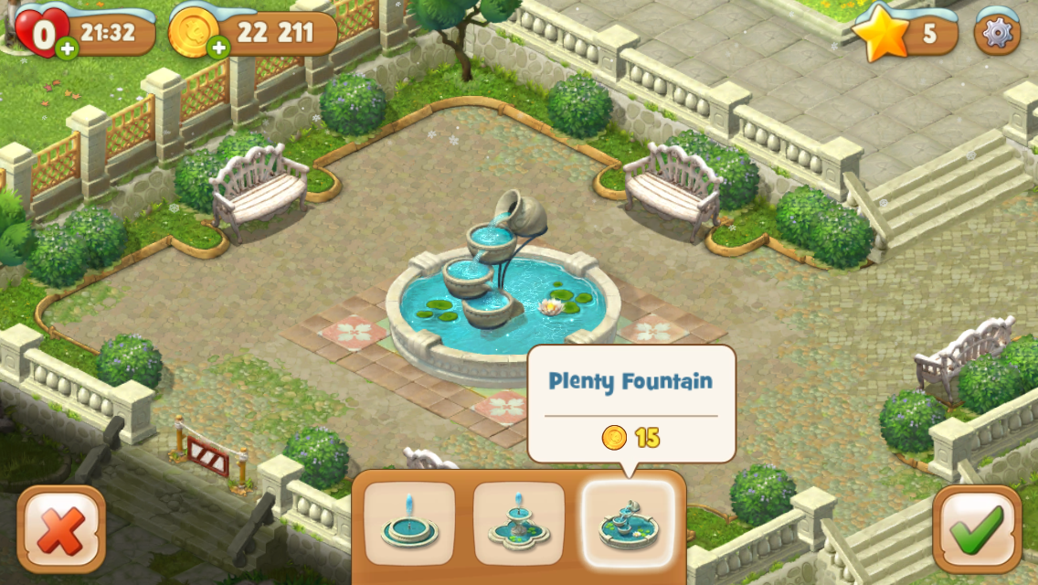

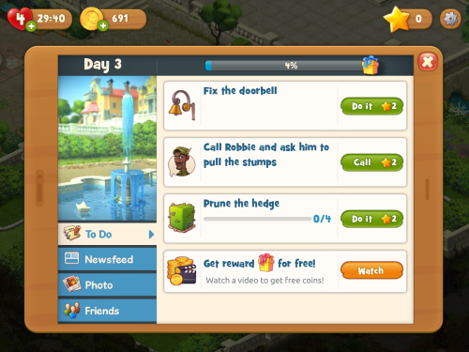

In Township

* Coins(the most common and easy to earn in game currency. You can also purchase them, the cheapest deal being £0.99 for 1850 coins, and the most expensive being £74.99 for 222.000 coins. The coins are used to purchase seeds and plant them, to expand the town by purchasing buildings and factories. You also need coins to be able to expand the town. The factories are the most expensive items in the game at the moment (I think). You can find coins in the mine, obtain in “present chests”, usually given as a daily reward, you can sell your products to earn some more, as well as exchange ingots for different amounts of money, depending on the rarity of the ingots. Depending on your level, the coins have more value in different areas, but I think this is enough information atm, you can ask me for more when we meet. )
* Township dollars (rarer to obtain, they can be bought with real money the cheapest deal being £1.99 for 50 dollars while the most expensive being £99.99 for 4000 dollars. They’re used for seasonal decorations, to buy objects not essential to the game such as gems, mine equipment and resources to expand the town and upgrade your barn. The barn is where all the items collected from the town are stored. In case you want to fulfil an order (train, airplane and such) and you don’t have the necessary items, you can also purchase them with township dollars, usually being at least 3 times more expensive then actually waiting and getting the items yourself. For example, 3 eggs will cost 24 township dollars, but to obtain you need 3 chicken food bags, which together cost 12 coins to make, and if the factory is updated it will take 23 minutes to produce 3 bags to feed the chicken. To speed up the process you can pay 2 dollars, and you have the bag instantly, then pay 2 more dollars to get the egg without having to wait. So, you can pay 4 coins and wait half an hour for an egg, or pay 4 dollars per egg. That would be 12 dollars to go through the progress and speed it up, or you can press one button and pay 24 township dollars. Sounds ridiculous, but it saves you 30 seconds at best, but some players won’t bother at all and would rather pay extra. Township dollars can be further used to add move slots to each factory, so while you’re away the said factory can produce one more of any item in the list. Carol could prefer to do this if she doesn’t have time to check her app during the day.
* Gems. You get access over level 50 when you unlock the laboratory. The laboratory basically gives you boosts, like for 2 days all customers give you twice the amount of coins they would normally pay. Gems can be bought with township dollars or rarely found as rewards in the Wheel of Fortune and in the mine. Further down the line when you unlock the zoo you need the gems to breed animals as well.
* Ingots. These are made from metals found in the mine which you then process in a factory. The ingots update your factories and trains, but they can also be sold to the mafia for 1 township dollar or be given in exchange at another factory for different amounts of coins. Furthermore, they can be sued when you sail your ships to other islands, since the rarer and more expensive the ingot, the bigger the chance of obtaining rarer stock and a random item.

